


JLR Ergonomics Specification

14.1 General

14.1.1 Any facility should be designed for ease of loading and unloading, an operator should not have to bend or stretch to reach a component or operate the equipment.

14.1.2 Consideration must be given to access in the design of the facility in relationship to the rest of the equipment / installation.

14.1.3 A full ergonomic assessment will be carried out on all operations that involve lifting, when the weight of the lift exceeds the LOLER specific targets. The Contractor, using standard formats from within their company will do ergonomic assessments. This will then be compared utilizing the JLR guidelines.

14.1.4 Wherever possible the People Size (1998) anthropometric data set should be used. Where the People Size anthropometric data set does not provide a suitable dimension, reference should be made to Adult data (1998).

14.1.5 Vendor to conduct PUWER assessments for all manual operations.

Detail

14.2.1 Standard methods and guidelines for anthropometric calculations associated with design for manufacture.

Information
    - The following detail provides information concerning the use of anthropometric percentiles when assessing different design scenarios for vehicle manufacture. The ergonomics physical data required in determining the optimum dimensions would differ depending upon the design scenario. The attached table provides the necessary information to determine the most appropriate worker population percentile to use for each design scenario.

Background

It is a misconception to assume that by designing for a single anthropometric percentile the result will be satisfactory for the entire worker population. The obvious risk to the business, by using a single anthropometric percentile for all simulations, is that the data may be inaccurate to base facility and vehicle design decisions on.

The most appropriate percentile will depend upon the task characteristics of each specific design scenario. For one-tailed constraints, e.g. reach, strength and clearance, it is vital that the appropriate extreme of the population be taken into account. This becomes imperative when designing safety critical systems

Additional Notes
Clothing:
When appropriate, a correction should be applied to the anthropometric data to take into account: footwear, outdoor clothing, and specialist protective clothing.

Safety:
Worker safety is of paramount importance. If there is perceived to be any risk of significant discomfort or injury associated with the design scenario the appropriate safety tolerances must be included in the design limits.

To calculate the extreme percentiles the equation below can be applied:

xp = m + sd (z)

Where xp is the percentile value to be calculated
Eg x99 is the 99th percentile value
m = mean
sd = standard deviation
- = standard deviate score

percentile | Z value
0.1 | -3.09
99.9 | 3.09

Percentiles:
For design scenarios involving reach, posture and strength the 50%ile female has been used as a lower limit. The decision to use the 50%ile female as the lower limit is based on the following reasoning:

Whilst the concept of universal design is an ideal the implications of designing for such a range is impractical and cost prohibitive.

The number of production employees who are likely to be adversely affected by the decision to use the 50th percentile female dimension as a lower limit is relatively small. There are a total of 287 female hourly paid workers at Land Rover Solihull. Based on a workforce of 8,000 employees at Land Rover Solihull, this represents 3.45%. Presuming a normal distribution of the female worker population the number of female hourly paid workers who fall below the 50%ile female dimension is approximately 144, representing 1.7% of the total number of employees. As such, for design scenarios involving either posture or reach, 1.7% of the total worker population will be potentially beyond the design limits used. This percentage represents less than one worker in 50, a small fraction of the total worker population. If the ratio of female to male workers significantly changes in the future the decision to use the 50th percentile female will need to be reviewed.
The validity, reliability and presentation of strength data in the literature is limited, making the calculation of different percentiles unfeasible.

JLR Ergonomics Team use the 50%ile female as a lower limit for design scenarios involving reach and posture.

Where the production environment does not fit the worker adequate measures must be implemented to ensure the worker is protected from discomfort or injury.

EXAMPLES OF DESIGN SCENARIOS
Design Scenario | Aim | Examples | Design to accommodate: | Notes
Reach | Placement to ensure access and appropriate and effective use | Leaning over jig | 50^{h} percentile female
Reach (with upper limit constraint) | Placement to ensure access and appropriate and effective use | Working under the vehicle | 50th percentile female to 95th percentile male
Clearance | Placement to avoid undesirable or unintentional contact | Reaching between two components | 95th percentile male
Clearance (safety critical) | Placement to avoid contact that may cause cuts, bruises, mechanical stress (friction) | Aperture into BIW panel | 95th percentile male PLUS 20%
Posture | Design to ensure comfortable and safe posture is adopted | Working surface height | 50th percentile female to 95th percentile male
EXAMPLES OF DESIGN SCENARIOS
Strength | Design to ensure operability | Insertion forces | 50^{h} percentile female | Any anthropometric strength calculation should take into account the posture of the upper limb and guidance values from other ergonomics standards: e.g. Dreyfuss tables & Strength data for design safety (phase 1 & 2) dti
Entrapment | Avoid unintentional retention of the whole body or body parts | Distance between two carriers | 99.9 percentile male | For safety critical situations a design criteria 4 standard deviations from the mean should be applied.  Where there is no risk of injury or discomfort associated with the potential entrapment the 95th percentile male may be used. Adequate assessment should be undertaken to determine the presence of risk.
Exclusion | Design to ensure inaccessibility and inoperability | Guarding, barriers, railings etc | The extreme range of the population  0.1 percentile female | Guidance / design standards should be sought from the H&S department. Where there is insufficient guidance the 99.9 percentile and 0.1 percentile should be used, which is approximately 3 standard deviations from the mean.
Vision | Design to ensure adequate sight of task and components | Engine compartment and interior trim tasks | 50th percentile female to 95th percentile male. * | *Where deemed appropriate the 50th percentile male may also be assessed in this design scenario to ensure a clear range of vision.

Anthro Table – for use in calculating distance and lift positioning

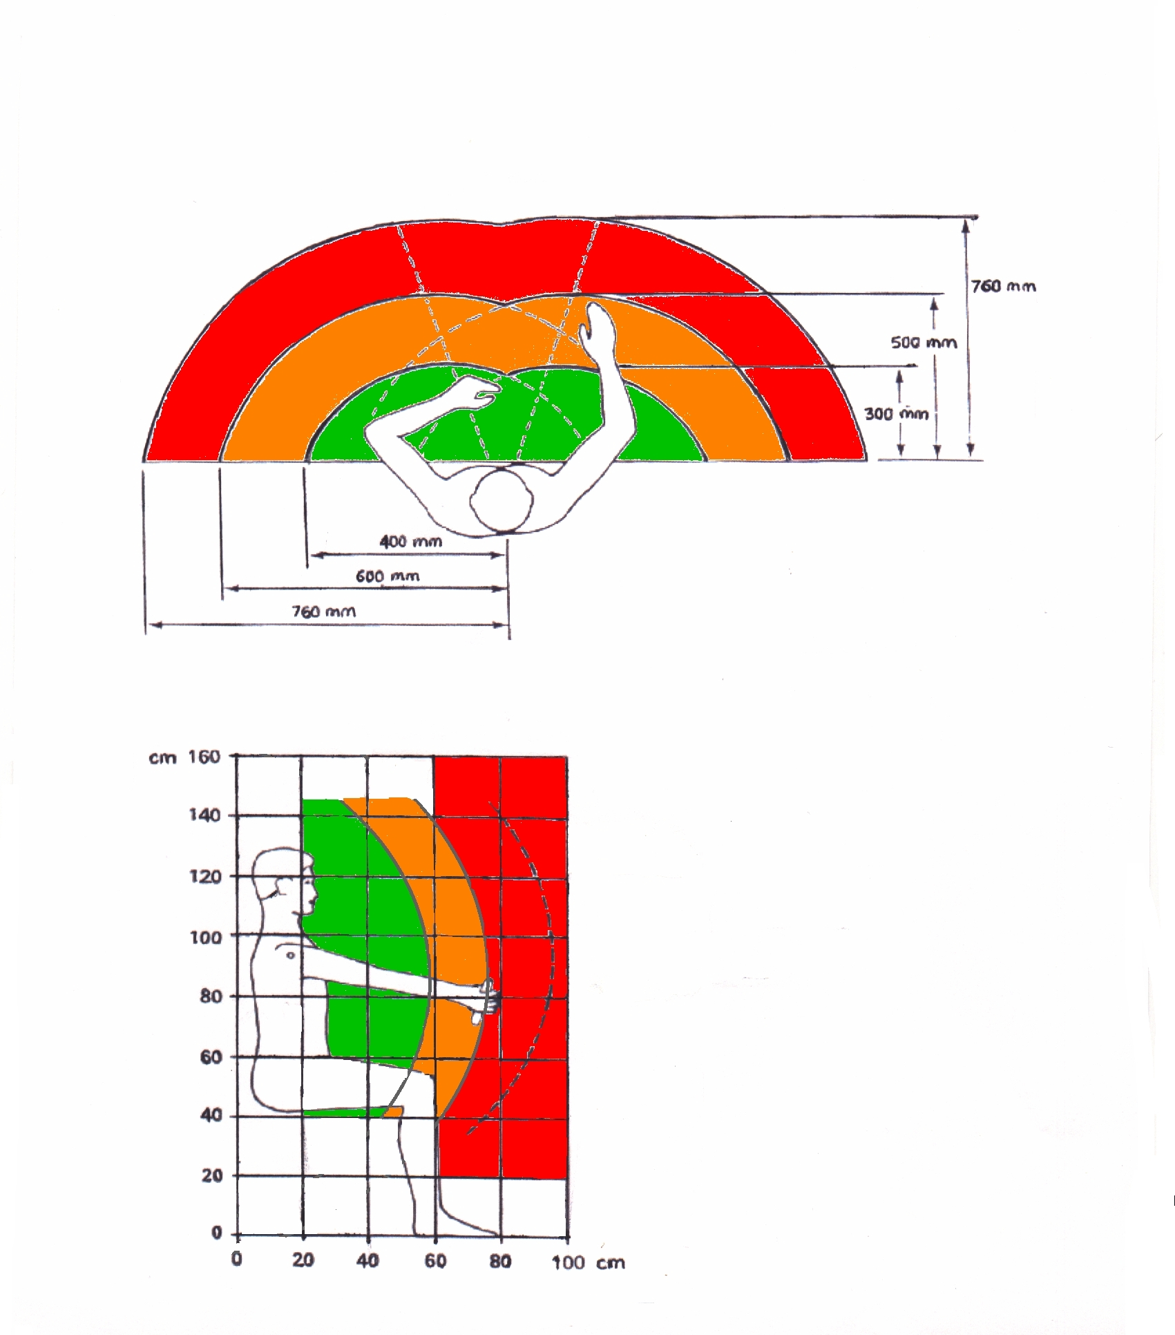

14.7 Example Check List for Welding Environment.
Ergonomic Checklist for New Projects – BIW Weld Jig Fixtures & Welding Process

Note: To be used in conjunction with Manual Handling Operations Risk (MHOR) Assessment & HSE guidance checklist on Upper Limb Disorders

Description of operation being assessed:

Reference Number;
Assessor(s) Name(s): Date Assessed:
Dept. / Function Signature

 | GREEN | RED | Comments
A. Is the object:-
to be held at points of width > 1700mm apart ? | NO | YES
to be held at a distance away from the body of >750mm ? | NO | YES
> 25kg in weight ? (if single person manually handling) | NO | YES
difficult to grasp ? (eg. slippery, smooth) | NO | YES
moved over a distance of greater than 10m by the Associate? | NO | YES
handled on a frequency of greater than twice per minute? | NO | YES
likely to be damaged easily if manually handled ?  (considering required quality standards ) | NO | YES
B. Does (Do) the Associate(s) have to:-
adopt any extreme postures to load / unload the fixture? | NO | YES
manually handle the object over a height of > 1600mm ? | NO | YES
hold the object's weight over an extended period of time without assistance? | NO | YES
perform other task elements whilst manually handling the object? | NO | YES
negotiate steps / stairs / slopes whilst manually handling the object? | NO | YES
Work within the red field of reach? (table 1) | NO | YES
Work within the red arc of vertical grasp? (table 2) | NO | YES
Work outside of the field of vision? (table 1) | NO | YES
Have to adopt a highly bent or rotated wrist position | NO | YES
D. Miscellaneous
Does the MHOR risk assessment identify significant hazards? | NO | YES
Is a mechanical handling aid currently being used successfully elsewhere for a similar application? | NO | YES
Does the HSE guidance notes on upper limb disorders identify significant hazards associated with the task? | YES | NO
Is there a history of accidents / injuries associated with the completion of this task? | NO | YES | Don't Know
Are the dials, displays and controls simple, logical and easy to read, reach and operate. | YES | NO
Are there any other obvious hazards associated with the task? (e.g: COSHH; sharp edges, temperature etc.) | NO | YES

